**CH1**

What is the system analyses, explain it and what are the skills required?

* The systems analyst assists and guides the project team so the team develops the right system in an effective way.
* Systems analysts must understand how to apply technology in order to solve problems.

Systems analysts may also serve as change agents who identify the organization improvements needed, design systems to implement those changes, and train/motivate others to use the systems.

Systems Analyst Skills

* Introduces change to the organization and people
* Leads a successful organization change effort
* Understands what to change and knows how to change it
* Must have technical skills, as well as, business skills
* Communicate effectively and give presentations
* Must be able to deal fairly, honestly, and ethically with other project members, managers, and systems users

What are the various kinds of Specializationin software Project team?

Systems Analyst

* The systems analyst focuses on the IS issues surrounding the system.
* Develops ideas and suggestions for ways IT can improve business process, helps design new business process, designs the new information system, and ensures that all IS standards are maintained.

Business Analyst

* Focuses on the business issues surrounding the system
* Identifies the business value that the system will create
* Develops ideas for improving the business processes
* Helps design new business processes and policies

Infrastructure Analyst

* Focuses on technical issues surrounding the ways the system will interact with the organization’s technical infrastructure
* Ensures that the new information system conforms to organization standards
* Identifies infrastructure changes

Change Management Analyst

* A change management analyst focuses on the people and management issues surrounding the system installation.
* Ensures that adequate documentation and support are available to users.
* Provides user training.
* Develops strategies to overcome resistance to change.

Project Manager

* Highly experienced systems analyst.
* Ensures that the project is completed on time and within budget.
* Makes sure the system delivers the expected values to the organization.

**What is system development cycle?**

* The **SDLC** is composed of four fundamental phases:

Planning

* This phase is the fundamental process of understanding why an information system should be built.

Analysis

* The analysis phase answers the questions of who will use the system, what the system will do, and where and when it will be used.
* During this phase the project team investigates any current system(s), identifies improvement opportunities, and develops a concept for the new system.

Design

* In this phases it is decided how the system will operate, in terms of the hardware, software, and network infrastructure; the user interface, forms, and reports that will be used; and the specific programs, databases, and files that will be needed.

Implementation

* During this phase, the system is either developed or purchased (in the case of packaged software).
* This phase is usually the longest and most expensive part of the process.

**What are the various kinds of Feasibility?**

* A Feasibility Analysis is used to provide more detail about the risks associated with the proposed system and includes:

**Technical feasibility.**

**Economic feasibility is also called a cost-benefit analysis.**

**Organizational feasibility.**

**What are cost benefits analyses and what is the major step?**

Step 1: Identify Costs and Benefits

Step 2: Assign Values to Costs and Benefits

Step 3: Determine Cash Flow

Step 4: Assess Project’s Economic

**CH2**

Explain the models or list them? *

* **Project Methodology Options**
* Waterfall Development
* Parallel Development
* V-model (variation of the Waterfall Development
* Rapid Application Development (RAD)
* Iterative Development
* Agile Development
* System Prototyping
* Throwaway Prototyping
* Extreme Programming

#You should read the book and see Advantages and Disadvantages for each one..

|  |  |
| --- | --- |
| **Project Elements System Request—Name of Project** | |
| **Project Sponsor:** | Name of project sponsor. |
| **Business Need:** | Short description of business need. |
| **Business Requirements:** | Description of business requirements. |
| **Business Value:** | Expected value that the system will provide. |
| **Special Issues / Constraints:** | Any additional information that may be relevant to the stakeholders. |

**Coordinating Project Activities**

Like all project management responsibilities, the act of coordinating project activities

continues throughout the entire project until a system is delivered to the project

sponsor and end users. This step includes putting efficient development practices in

• Clearly define plans for the project.

• Make sure the team understands how the project is important to the organization.

• Develop detailed operating procedures and communicate these to the team members.

• Develop a project charter.

• Develop schedule commitments ahead of time.

• Forecast other priorities and their possible impact on project.

CH3

What are the requirements and its type? *

* A statement of what the system must do
* A statement of characteristics the system must have
* Focus is on business user needs during analysis phase
* Requirements will change over time as project moves from analysis to design to implementation

**Requirement Types:**

* **Functional Requirements**
  + A process the system has to perform
  + Information the system must contain
* **Nonfunctional Requirements**
  + Behavioral properties the system must have
    - Operational
    - Performance
    - Security
    - Cultural and political

*What are the three models of identifying requirement? “We are Move from as is system to to be system”

* Three techniques help users discover their needs for the new system:

**Business Process Automation (BPA)**

**Business Process Improvement (BPI)**

**Business Process Reengineering (BPR)**

List the various kind of requiring gathering technique:

**Interviews**

**Joint Application Development (JAD)**

**Questionnaires**

**Document Analysis**

**Observation**

**CH4**

**Use case;**

* A ***use case*** is a set of activities that produce some output result
* Describes how the system reacts to an **event** that **triggers** the system
* Trigger -- event that causes the use case to be executed
* **Event-driven modeling** – everything in the system is a response to some triggering event
* All possible responses to the event are documented
* Use cases are helpful when the situation is complicated

**List the components of use case?**

* **Basic information**
  + Name, number and brief description
  + Trigger – event that causes the use case to being
    - External trigger – some from outside the system
    - Temporal triggers – time-based occurrences
  + Viewpoint of the use cases should be consistent
* **Major inputs and outputs**
  + Sources and destinations
  + Goal is to be all inclusive
* **Details**
  + Steps performed and the data inputs and outputs

**CH5**

**You can be given DFD diagram and ask to list the data stores, entity and pressers?**

**#you can see the examples from slides and the revision Lecture by D. Hala**

What is the A process model?

A process model is a graphical way of representing how a business system should operate.

What is the Data flow diagramming (DFD) ?

Data flow diagramming is a technique that diagrams the business processes and the data that pass among them.

**Elements of a DFD**

* **Process**
  + An activity or function performed for a specific business reason
  + Manual or computerized
* **Data flow**
  + A single piece of data or a logical collection of data
  + Always starts or ends at a process
* **Data Store**
  + A collection of data that is stored in some way
  + Data flowing out is retrieved from the data store
  + Data flowing in updates or is added to the data store
* **External entity**
  + A person, organization, or system that is **external** to the system but interacts with it. “Lawn Chemical Applicator (LCA)”

**Difference between various levels of DFD ?**

**Context Diagram**

* First DFD in every business process
* Shows the context into which the business process fits
* Shows the overall business process as just ***one*** process (process 0)
* Shows all the external entities that receive information from or contribute information to the system

**Level 0 Diagram**

* Shows all the major processes that comprise the overall system – the internal components of process 0
* Shows how the major processes are interrelated by data flows
* Shows external entities and the major processes with which they interact
* Adds data stores

**Level 1 Diagrams**

* Generally, one level 1 diagram is created for every major process on the level 0 diagram
* Shows all the internal processes that comprise a single process on the level 0 diagram
* Shows how information moves from and to each of these processes
* If a parent process is decomposed into, for example, three child processes, these three child processes wholly and completely make up the parent process

**Level 2 Diagrams**

* Shows all processes that comprise a single process on the level 1 diagram
* Shows how information moves from and to each of these processes
* Level 2 diagrams may not be needed for all level 1 processes
* Correctly numbering each process helps the user understand where the process fits into the overall system

**Difference between logical and physical process models?**

* ***Logical***process models describe processes without suggesting how they are conducted
* ***Physical*** process models provide information that is needed to build the system

**“IT will be given a use case and asking to list the components or Entity and draw a DFD level-1 or E-R”**

**Use case example:**

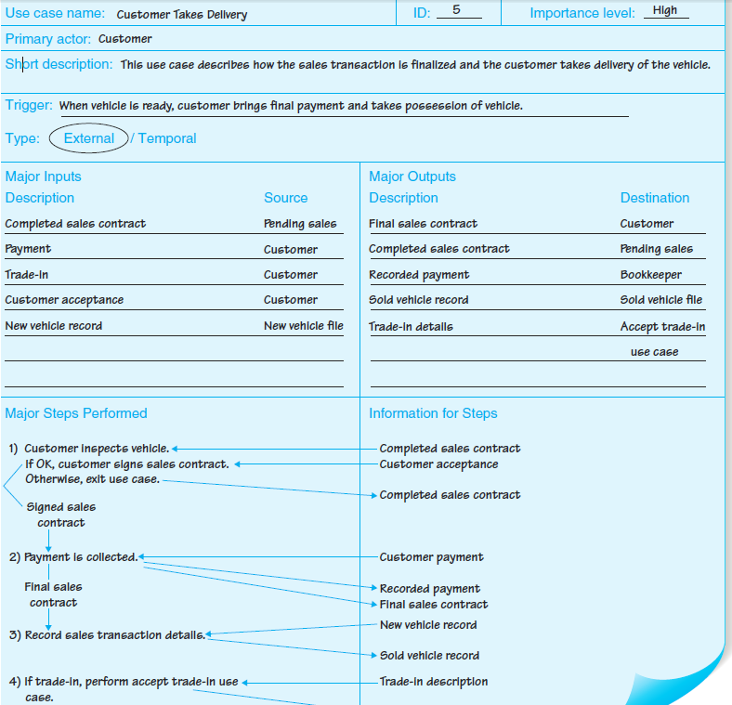

**Data Flow Diagram Elements:**

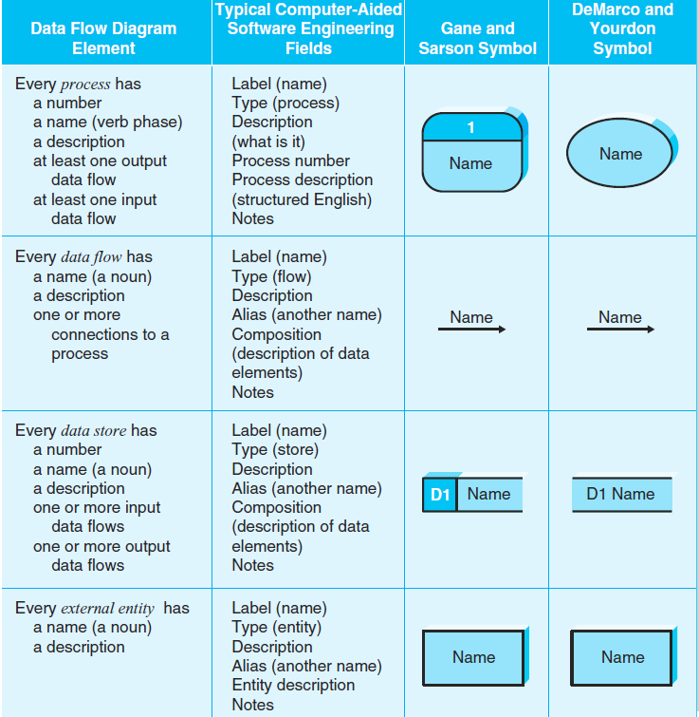

**Example for DFD level 1:**

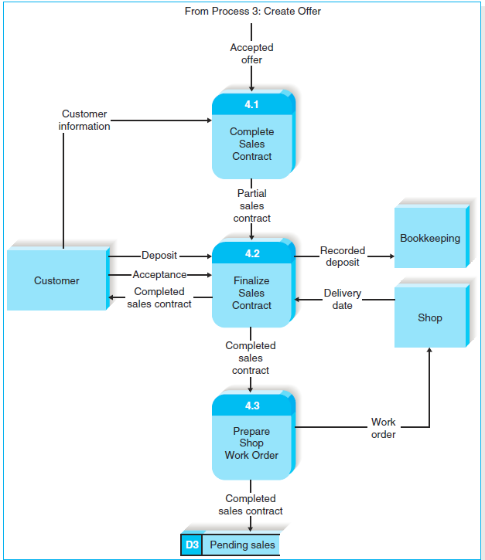

**CH6**

What Is an ERD?

* A picture showing the information created, stored, and used by a business system.
* Entities generally represent similar kinds of information
* Lines drawn between entities show relationships among the data
* High level business rules are also shown

**Explain the components of E-R and know everything belong to components in the E-R?**

**Entity**

* A person, place, event, or thing about which data is collected
* Must be multiple occurrences to be an entity
  + Example: If a firm has only one warehouse, the warehouse is not an entity. However, if the firm has several warehouses, the warehouse could be an entity if the firm wants to store data about each warehouse instance.

**Attributes**

* Information captured about an entity
* Only those used by the organization should be included in the model
* Attribute names are nouns
* Sometimes entity name is added at the beginning of the attribute name for clarity

**Identifiers**

* One or more attributes can serve as the entity **identifier**, uniquely identifying each entity instance
* **Concatenated identifier** consists of several attributes
* An identifier may be ‘artificial,’ such as creating an ID number
* Identifiers may not be developed until the Design Phase

**Relationships**

* Associations between entities
* The first entity in the relationship is the ***parent*** entity; the second entity in the relationship is the ***child*** entity
* Relationships should have active verb names
* Relationships go in both directions

Data Modeling Symbol Sets:

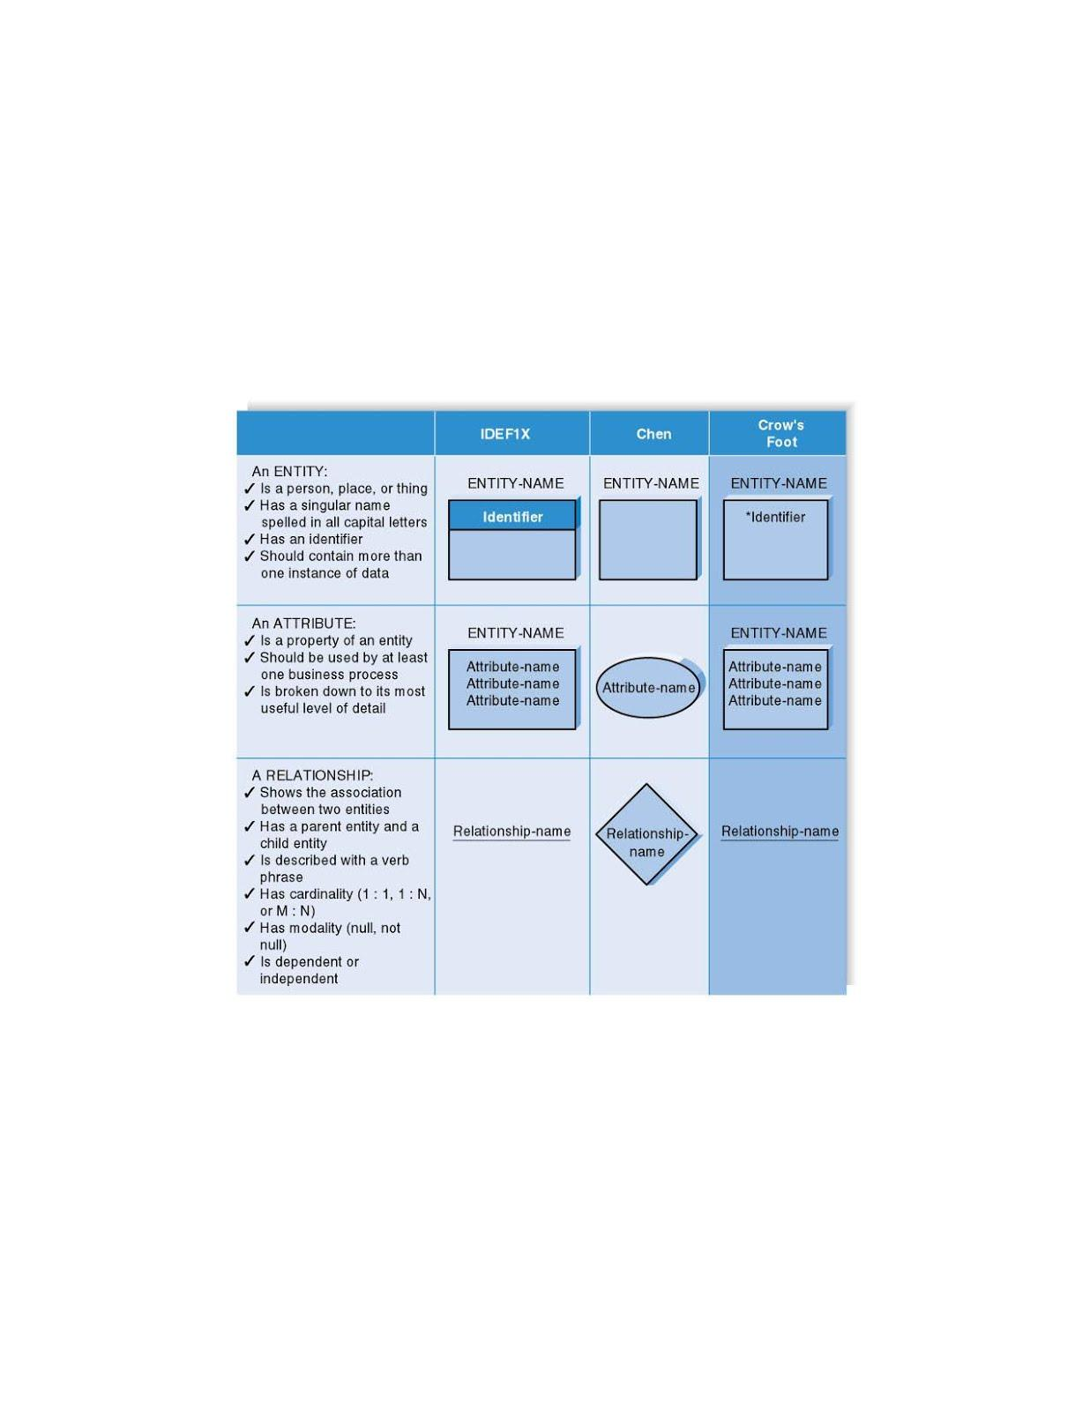

**Example for ERD – Super Market:**

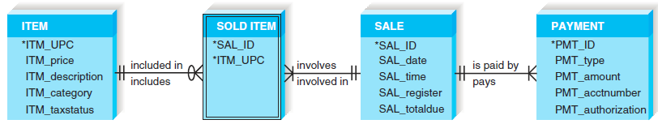

**Cardinality**

* refers to the number of times instances in one entity can be related to instances in another entity
* One instance in an entity refers to one and only one instance in the related entity (1:1)
* One instance in an entity refers to one or more instances in the related entity (1:N)
* One or more instances in an entity refer to one or more instances in the related entity (M:N)

**Modality**

* Refers to whether or not an instance of a child entity can exist without a related instance in the parent entity
* **Not Null** means that an instance in the related entity must exist for an instance in another entity to be valid
* **Null** means that no instance in the related entity is necessary for an instance in another entity to be valid

**The Data Dictionary and Metadata**

* Metadata is information stored about components of the data model
* Metadata is stored in the data dictionary so it can be shared by developers and users throughout the SDLC
* A complete, shareable data dictionary helps improve the quality of the system under development

**What is the normalization? What are the first three levels?**

* ***Normalization* is the process analysts use to validate data models.**
* Technique used to validate data models
* Series of rules applied to logical data model to improve its organization
* Three normalization rules are common

**First Normal Form (1NF)**

Look for repeating groups of attributes and remove them into separate entities.

**Second Normal Form (2NF)**

If an entity has a concatenated identifier, look for attributes that depend only on part of the identifier. If found, remove to new entity.

**Third Normal Form (3NF)**

Look for attributes that depend only on another non-identifying attribute.

If found, remove to new entity. Also remove any calculated attributes